Notes 5.1 Graphing Translations of Square Root Functions

The square root PARENT function is $f(x)= \sqrt{x}$. Fully written, it is $f(x)=a\sqrt{b(x-h)}+k$.

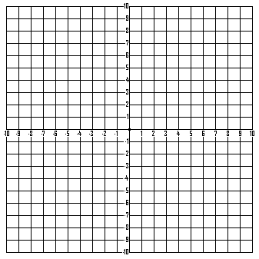
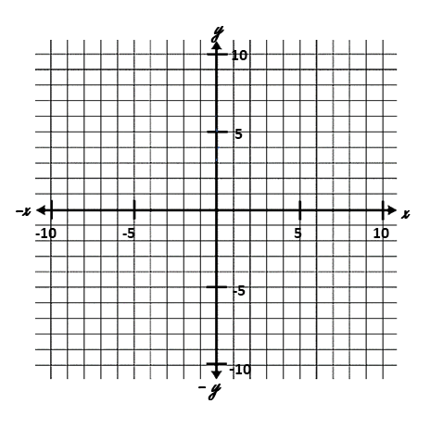
The parent function is $f(x)= \sqrt{x}$. Make a t-chart and graph the parent function to the right.

D_____________R________________




1. $g(x)= \sqrt{x-1}$ 2. $g(x) = \sqrt{x}+2$


D_________________________ D_________________________
R_________________________ R_________________________
Using $f(x)= \sqrt{x}$ as the original function write g(x) in terms of f(x).
____________________________ ___________________________
Describe the translation.
_________________________________________ __________________________________________



3. $g\left(x\right)=\sqrt{x+1}-2$ 4. $g(x)= \sqrt{x-3}+4$

D_____________R____________ D_____________R____________
Using $f(x)= \sqrt{x}$ as the original function write g(x) in terms of f(x).
____________________________ ___________________________
Describe the translation.
_________________________________________ __________________________________________


5. $g(x)= \sqrt{x+8}-2$ 6. $y = \sqrt{x-4}+2$

D_____________R____________ D_____________R____________
Using $f(x)= \sqrt{x}$ as the original function write g(x) in terms of f(x).
____________________________ ___________________________
Describe the translation.
_________________________________________ __________________________________________
Given the following descriptions write the new function then write g(x) in terms of f(x).
9. The parent function $f\left(x\right)= \sqrt{x}$ is translated up 9 units.
10. The parent function $f\left(x\right)= \sqrt{x}$ is translated 4 units to the left down 7 units.

